[9-12] Building a Culture of Math Learning Session 10 Facilitator’s Guide

Summary
Effective teaching of mathematics requires cultivating a culture of math learning within the classroom - this culture encourages students to take academic risks, to persevere when content becomes challenging, to utilize a myriad of mathematical tools and models to approach new problems, to share their own thinking, and to offer feedback on the thinking of others. To cultivate this kind of culture, teachers must model through words and actions the importance of grappling with content to build a deep understanding; they must equip students with the content knowledge and problem solving tools to find multiple pathways to a given solution; and they must facilitate regular opportunities for students to engage in the practices of mathematics, including analyzing their own misconceptions and refining their approaches as part of the learning process.

Throughout this content cycle, teachers will explore these instructional moves and connect them directly to the mathematical content and standards for mathematical practices within the Kentucky Academic Standards (KAS) for Mathematics. While this content cycle will do a deep dive of the 3 Standards for Mathematical Practice indicated below, the KAS for Mathematics require teachers to implement all 8 Standards for Mathematical Practice. To support teachers in elevating different SMPs during their instruction, the KAS for Mathematics tag relevant MPs to every content standard. The inclusion of those tagged MPs does NOT mean those are the only ways students can engage in the practices while learning that content. The inclusion of tagged MPs also doesn’t mean that those practices automatically happen throughout instruction on that content standard. How instruction is designed will determine how students engage with the content. This content cycle will support educators in purposefully planning and designing instruction to provide students with opportunities to engage in the practice standards while engaging with the content standards.

This content cycle focuses specifically on:
- SMP1. Make sense of problems and persevere in solving them
- SMP4. Model with mathematics
- SMP3. Construct viable arguments and critique the reasoning of others

See the Mathematics Professional Learning Modules for additional learning around the Standards for Mathematical Practice or for guidance/support with implementing the KAS for Mathematics.

Essential Questions
- How do the Standards of Mathematical Practice support teachers in creating and sustaining a culture of learning in math classrooms?
- How can teachers explicitly introduce and authentically incorporate the Standards of Mathematical Practice within their instruction?
- How can teachers create a “culture of error” where students feel comfortable taking academic risks, struggling through high-quality tasks and discussing their misconceptions to advance their own learning?
- Specifically, how can an emphasis on problem-solving (SMP 1), modeling to understand “concepts before procedures” (SMP 4) and justification of answers (SMP 3) create an environment where students are encouraged to own their own learning?

Enduring Understandings
- Teachers should communicate that perseverance, which requires a willingness to take risks and make mistakes, is a critical part of the learning process.
- In order for students to own their own learning, teachers intentionally design instruction which places equal value on the development of mathematical content and mathematical practices.
- True conceptual understanding of math comes from connecting multiple representations (concrete, representational/pictorial, and abstract).
- To build deep and enduring understanding of math, teachers must place emphasis on the “how” and “why” and push students to justify their answers,
- Meaningful teacher and peer feedback allow for students to monitor their progress toward learning outcomes and provides students with opportunities to reflect on their own learning.

Key Components of Cycle
The Learning Cycle includes the following components to support shifts in instruction:
- Shared Learning: Learning sessions where teachers learn new knowledge and skills aligned to the topic of the content cycle. This might be designed in a variety of ways, including reading and discussing an article, studying a classroom video or doing some group practice of a particular planning component.
- Planning & Practice: Opportunities for teachers to apply the content they are learning within this content cycle to review/revise classroom instruction. This could include analyzing units/lessons using tools to evaluate alignment to the KAS for Mathematics, rehearsing lessons, watching and reflecting on videos of their classroom practice, etc.
- Student Progress Monitoring: This is an opportunity for teachers to examine student progress aligned to the topic of the cycle. This can include formative student work analysis, end of unit assessments, culminating tasks, etc.

Over the course of this 12-week learning cycle, teachers will:
- Examine instructional materials and tasks using the KAS for Mathematics and supporting resources;
- Consider the implications of these materials as they relate to changes in both teacher planning and practice;
- Engage in lesson study, practice in content delivery and peer-feedback, and reflect on progress by regularly revisiting goals and analyzing student data

Note that these components do not necessarily happen in a perfect rhythm. For example, depending on the content, there may be several shared learning sessions before a planning & practice, or there may be several cycles of shared learning and planning & practice before student progress monitoring.

Session | Type of Learning | Objective(s) | Supporting KAS Resources | Assessment of Learning
Session 10 | Shared Learning Focusing on SMP 3 | - Analyze specific teacher planning and instructional moves around incorporating SMP 3 within the lesson and the impact on student learning | - KAS for Mathematics  - Engaging the SMPs: Look fors and Question Stems | - Session tasks: Create a student exemplar, video observation notes, plan discussion probes/scaffolds  - Self-reflection

Preparation:
This Facilitator’s Guide is designed to accompany
- [9-12] BCML Session 10 PowerPoint
Participants should be given access to the following documents to engage in the learning for this session:
- [9-12] BCML Session 10 Handout 1

Session Agenda Time (75 min)
- Slides 1 - 4: Welcome, norms, objectives & agenda (10 min)
- Slides 5-6: Connection to Prior Learning: SMP 3 (7 min)
- Slide 7-8: Read the standard/clarifications, create a student exemplar for an aligned task, task share out (19 min)
- Slides 9-11: Video observation, video share out, instruction share out (18 min)
- Slide 12: Connection to Equity (4 min)
- Slide 13: Criteria for Success (5 min)
- Slide 16 - 18: Reflection, closing whip around, what’s next (12 min)

Facilitator Notes | Accompanying Slide
Slide 1:  (1 min) Welcome teachers to the session. | 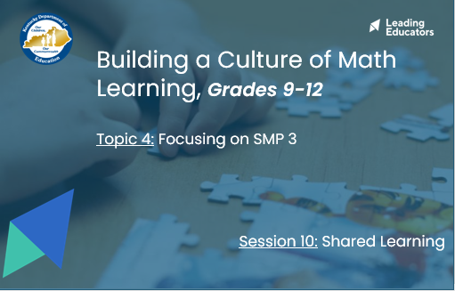
Slide 2:  (1 min) Welcome teachers to the session.  (2 min) Facilitator says:  - “Here you’ll see our 12-week arc of learning. Can I have someone read out our guiding principle in the yellow box?”  - “In green, you’ll see our four major topics of learning. For each topic of learning, we’ll engage in a three-week learning cycle that will include a shared learning session, a planning and practice session, and a student progress session. Our first topic of learning included an overview of all 8 Mathematical Practices. In the next 3 topics, we’ll narrow our focus to cover just one SMP at a time so we can better internalize and apply our learning. As you’ll see, the three SMPs we will focus on are:  - Standard for Mathematical Practice 1: Make sense of problems and persevere in solving them.  - Standard for Mathematical Practice 4: Model with mathematics.  - Standard for Mathematical Practice 3: Construct viable arguments and critique the reasoning of others.”  - “While this content cycle will do a deep dive of 3 Standards for Mathematical Practice, the KAS for Mathematics require teachers to implement all 8 Standards for Mathematical Practices. To support teachers in elevating different SMPs during their instruction, the KAS for Mathematics tag relevant SMPs to every content standard. The inclusion of those tagged SMPs does NOT mean those are the only ways students can engage in the practices while learning that content. It also doesn’t mean that throughout instruction on that content standard those practices automatically happen. How instruction is designed will determine how students engage with the content. See the KY Standards Mathematics Professional Learning Modules for guidance.”  - [CLICK for animation] “You’ll see that today we are continuing our learning with Topic 4 - Focusing on SMP 3: Construct viable arguments and critique the reasoning of others”.  - [CLICK for animation] “Our first session in this topic will be shared learning, where we can build a bank of common experiences and language to use throughout this content cycle.” | 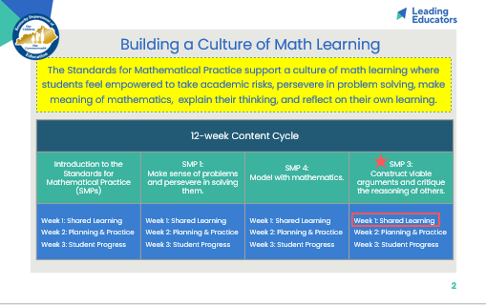
Slide 3:
(5 min) Review team norms and/or facilitate a quick team connector/icebreaker.

Slide 4:  (2 min) Ask teachers to popcorn out the objectives and agenda. Facilitator says:  - “By having a concrete example of what SMP 3 looks like (in terms of teacher moves and impact on student learning), we’ll be better able to consider how to incorporate this SMP into our practice. Like our past shared learning sessions, we’ll be using our annotated Lesson Planning tool to help us engage in “intellectual prep work” which includes considering the standard context and completing the same task seen in the video. This way, we’ll flex our own skills of “doing the math” and “experiencing the learning” which will give us a better lens for the video observation. | 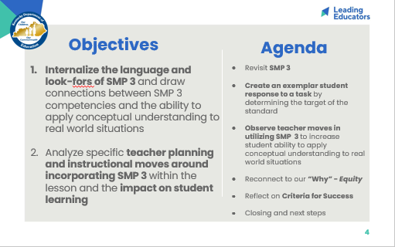
Slide 5:
(< 30 sec) Facilitator says:
- “Let’s preview the criteria for success that will guide our learning for this entire topic. Take 2 silent minutes to mark up the MTPs that will support our students in engaging with the focus SMP on Handout 1 - Page 5.”

(2 min) Teachers take 2 minutes to read criteria for success.

(< 30 sec) Facilitator says:
- With a partner, draw parallels between the MTPs (what teachers are doing) and the SMPs (what students are doing as a result).”

(2 min) Teachers take 2 minutes to read criteria for success.

*Note: Listen for and reinforce these key ideas...
- There are many connections between the MTPs are SMPs. Teachers may highlight connects between:
  - MTP 2/4 and SMP 3 - Teachers must offer student rigorous tasks that are “worthy of discussion.” Rich discussion around the key concepts of mathematics is not likely to happen if students are only given procedural or rote tasks. Teachers must create systems/structures for students to engage in whole group or small group conversation around misconceptions and critique one another’s reasoning.
  - MTP 5/8 and SMP 1 - In order for student discussions to lead for clarified understanding, teachers must ensure that students have differentiated access points to the key mathematics of the lesson so that all students can engage in learning. By asking purposeful questions and adjusting instructional supports based on student answers, teachers can ensure that all students can make sense of grade-level tasks and consolidate their understanding.
- This list of connections is not exhaustive; teachers may find other connections and justify their own rationale for how those teacher practices model, encourage, and support students in engaging with the SMPs.

(< 30 sec) Facilitator says:
- “As we engage in shared learning today, continue to return to these criteria and consider how today’s learning is supporting your growth and progress in these indicators.”

Slide 6:  (1 min) Facilitator says:  - “We’ll take 2 minutes to review our takeaways on SMP 3. You can revisit your notes from our first shared learning session (Session 1) or revisit the KAS for Mathematics “Engaging the SMPs: Look-fors & Question stems”.  (2 min) Teachers jot down their reflections on post-it notes. | 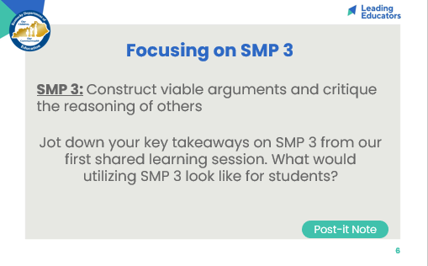
Slide 7:  (2 min) Have 1 or 2 teachers share.  (2 min) [CLICK for animation] Connect teachers shared ideas and iterate the any bullets that may have been missed.  *Note: Listen for and reinforce these key ideas...  - The statements above come from the KAS for Mathematics - Standards for Mathematical Practice. The above statements have been highlighted from longer text, which can be found here (page 13):  - “Mathematically proficient students understand and use stated assumptions, definitions and previously established results in constructing arguments. They make conjectures and build a logical progression of statements to explore the truth of their conjectures. They are able to analyze situations by breaking them into cases and can recognize and use counterexamples. They justify their conclusions, communicate them to others and respond to the arguments of others. They reason inductively about data, making plausible arguments that take into account the context from which the data arose. Mathematically proficient students also are able to compare the effectiveness of two plausible arguments, distinguish correct logic or reasoning from that which is flawed and—if there is a flaw in an argument—explain what it is. Elementary students can construct arguments using concrete referents such as objects, drawings, diagrams and actions. Such arguments can make sense and be correct, even though they are not generalized or made formal until later grades. Later, students learn to determine domains to which an argument applies. Students at all grades can listen or read the arguments of others, decide whether they make sense and ask useful questions to clarify or improve the arguments.” | 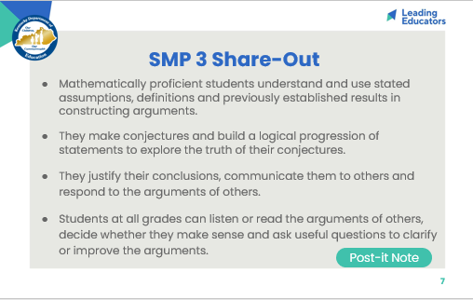
Slide 8:  (2 min) Facilitator says:  - “Last topic, we watched videos where teachers incorporated a variety of SMPs in their lesson and turned a particular eye toward noting evidence of SMP 4. Today, we’re going to zone in and look for evidence of SMP 3 specifically. Over the course of the year, SMPs 1, 4, and 3 will be our focus SMPs - the ones we’ll practice, reflect on, and refine. While all the SMPs are important, we believe that SMPs 1, 4, and 3 are particularly high leverage - they create a culture where students are willing to take risks and persevere through challenging math, as well as give students the methods to struggle productively as they approach grade-level work/tasks. Ultimately, developing student proficiency in SMPs 1, 4, and 3 will pave the way for our students’ development in mastering other SMPs in the future.”  - “While this content cycle will do a deep dive of 3 Standards for Mathematical Practice, the KAS for Mathematics require teachers to implement all 8 Standards for Mathematical Practices. To support teachers in elevating different SMPs during their instruction, the KAS for Mathematics tag relevant SMPs to every content standard. See the KAS for Mathematics document and the KY Standards Mathematics Professional Learning Modules for guidance.”  - [CLICK for animation] “Similar to previous shared learning experiences, we’ll use an annotated lesson planning tool to help us internalize the task that we will watch in today’s video. The lesson planning tool helps us identify the targets of the standard evident in a task, whether we’re planning a full lesson or simply preparing to create an exemplar student response. The same “intellectual prep” work we do when we lesson plan applies directly to internalizing tasks.”  - “Because we’re not planning a full lesson, some of the lesson planning tool has been pre-filled or annotated for you already. We’ll be focusing on just the Do the Math, Target of the Standard, and Standards for Mathematical Practice portions of the lesson planning tool.”  (5 min) Facilitator says:  - “Let’s start by reviewing the standard and completing the task, so we can start with ‘the end in mind.’”  - “Please take 5 minutes to complete the Do the Math, Target of the Standard, and Standards for Mathematical Practice portions of the lesson planning tool.”  - “Remember, as we engage with the new KAS for Mathematics, we may need to do additional work to break down the standard before we dive into lesson planning and creating an exemplar student response to an aligned task. Teachers are encouraged to use the Breaking Down a Mathematics Standard tool (also found in the BCML Appendix) to continue to deepen their understanding of content standards.” | 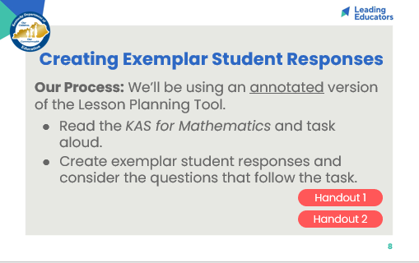
Slide 9:  (10 min) Review the Do the Math, Target of the Standard, and SMP sections on the annotated lesson plan tool.  - Ask teachers to consider this guiding question as they share, “What types of methods (concrete, representational, and/or abstract) does your exemplar include? How do those methods support students in accessing the target of the standard presented in the task?”  *Note: Listen for and reinforce these key ideas...  - The target of the standard presented in this task is application. Students must determine the relationship among 3 independent variables (wide diameter, narrow diameter, and slant height) and 1 dependent variable (roll radius). This task pushes students to apply their understanding of similar triangles to determine the radius of the circle created by cups by extending those cup shapes into cones.  - Exemplar student responses may pay particular attention to data points where a change in one independent variable (with the other independent variables held constant) results in a change in the dependent variable.  - For example, Cups A, F, and H have the same wide diameter and slant length; however, their narrow diameter lengths vary. Cup A has the largest narrow diameter and the largest roll radius of the three. Cup F has the second largest narrow diameter and the second largest roll radius of the three, etc. Students should observe that an increase in narrow diameter is correlated with an increase in roll radius.  - Possible misconceptions might include:  - Students may not identify the correlating parts of the similar triangles and be unable to set up a proportional relationship.  - Facilitators should point teachers toward the Attending to the Standards for Mathematical Practice and clarifications for this standard found on page 218 in the Kentucky Academic Standards document. Specifically, students should be able to “routinely use various methods of proof (formal, informal, direct and indirect) to outline their logic in order to defend their conjectures (MP.3).” | 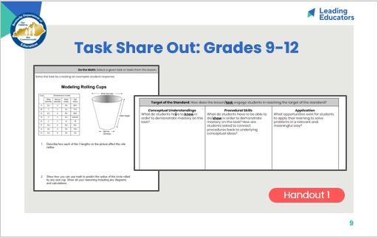
Slide 10:  (1 min) Facilitator says:  - “We’ll likely see evidence of multiple SMPs being taught by the teacher and being utilized by the students because the SMPs work in conjunction and build upon one another. While you’re encouraged to note how the teacher employs multiple SMPs, I do want us to look out for SMP 3 specifically. As you watch, record evidence of how the teacher incorporates SMP 3 into this lesson. You might choose to script what the teachers says or describe the action the teacher takes. What evidence do we have of the impact of SMP 3 on student learning? What are students saying and/or doing?  - “Remember, the video we’re watching isn’t perfect instruction - Try to focus on what’s effective about the teacher moves we see here. Afterward, we’ll share our own experiences with this practice and discuss ways we can continue to evolve and refine our usage of the SMPs.”  (7 min) Play video clip (min 0:00-6:25).  (2 min) Facilitator says:  - “Take another 2 minutes to finish up your notes. Again, like last week, I’d like you to consider the “behind the scenes” prep and planning the teacher might have done in order to incorporate SMP 3 into this lesson. Finding opportunities to amplify SMPs during our lesson doesn’t just happen; we need to determine ahead of time which specific SMPs will support and/or extend the learning experience for our students. While we don’t see the lesson plan or hear about the planning process in this clip, what prep work can infer the teacher did to successfully connect this specific lesson’s objective(s) to SMP 3? You can include those notes in the box below the chart.” | 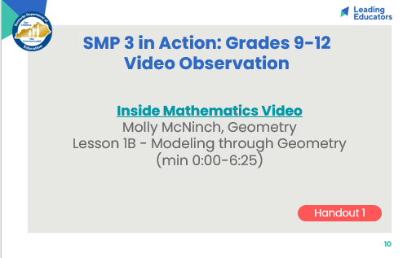
Slide 11:  (2 min) Facilitator says:  - “Let’s visit our observation notes and the planning steps we’ve inferred from the video.”  *Note: Listen for and reinforce these key ideas…  - The teacher selected/modified/created* a task that required students to make sense of a real world problem (SMP 1). The task has been designed to also draw upon SMP 4 (written out explanations, equations, tables, and graphs).  - The task as written does NOT call upon SMP 3; SMP 3 is addressed through the teacher’s facilitation of the task (to be discussed on the next slide).  * It is important to iterate for teachers that their curriculum may have KAS-aligned tasks that are ready for implementation and other times the curriculum may need tasks to be revised or created to align the KAS. Within one curriculum, alignment of lessons and tasks may vary from topic to topic. Teachers are encouraged to use the Assignment Review Protocol to evaluate tasks within their curriculum to ensure alignment to the KAS before using those tasks with students. Alternatively, teachers may use the Assignment Review Protocol as a rubric to support the revision and/or creation of new tasks.  (3 min) Facilitator says:  - [Click for animation] “Let’s visit our observation notes and the instructional moves we saw in the video.”  *Note: Listen for and reinforce these key ideas…  - Ms. McNinch has students engage in a task that requires them to make sense of the problem and discuss their reasoning with their teammates (SMP 3).  - She opens by telling students that they must show their thought process. In their discussion with groups, they must explain their thinking and then build/critique each other’s reasoning to build a “joint solution that is better than individual responses.”  - Students explain their thinking to one another as they make hypotheses about the relationship wide diameter, narrow diameter, slant length, and roll radius. When pushed to elaborate how they got to their hypotheses, students share methods of plug and chug, noticing differences between cups with constant wide diameters/slant diameters but different narrow diameters (i.e. cups A and F) and how the change in that variable impacted the overall roll radius. | 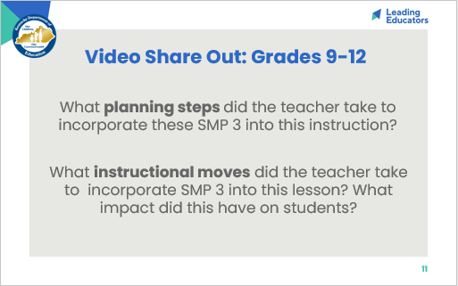
Slide 12:  (2 min) Teachers share their own experiences with utilizing SMP 3.  - Reflections from the video may prompt teachers to share their own best practices and consider adjustments/new learning based on the video. | 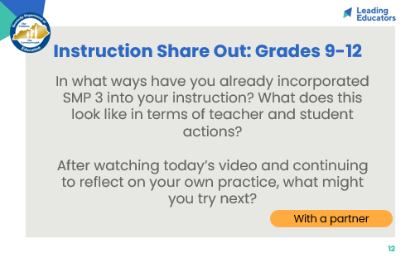
Slide 13:  (5 min) Facilitator says:  - “In previous sessions, we saw teachers use a task that was already aligned to the KAS content standard AND the focus practice standard. In this particular video observation, the teacher’s task meet the target of the content standard (conceptual understanding and application) as well as had clear connections to SMP 4. | 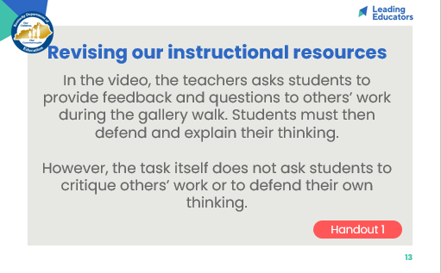
Slide 14:  (5 min) Facilitator says:  - “This teacher wanted to focus on SMP 3 as well - what changes did she make to her instruction to ensure students could engage with SMP 3?”  *Note for 9-12: Listen for and reinforce these key ideas…  - She adjusted her instruction (or the classwork surrounding the task) by having students work in small groups so that they had the opportunity to collaborate, offer feedback on one another’s thinking, and explain their own reasoning.  - She could have chosen to re-word the task itself to specifically ask students to provide explanations for their work.  - Both revisions would push this learning experience to engage with SMP 3. | 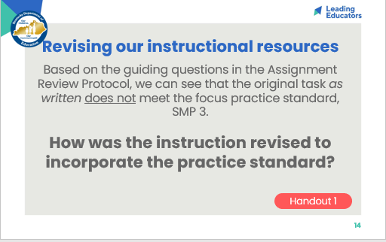
Slide 15:  (3 min) Facilitator says:  - “Similarly, we might find that tasks we have in our existing curriculum might need to be updated in order to align to the KAS practice standards we want to highlight. As educators, we can make these adjustments in our planning and/or in our facilitation of the lesson (in our instruction).”  - “While we are not going to plan a full lesson based on this task, let’s take a moment to think ahead to the lesson planning tool we’ll use in next week’s Planning & Practice session - using today’s revised task as an example, let’s take a moment to consider a process we can use to evaluate if a lesson/task is aligned to the KAS and if not, determine how we can respond to the gaps in that lesson/task. On a post-it, take 2 minutes to “outline” a process or questions you might ask yourself to 1) evaluate a current curricular resource for alignment to the KAS content AND practice standards and 2) to adjust that resource if it doesn’t fully align to the standard.” | 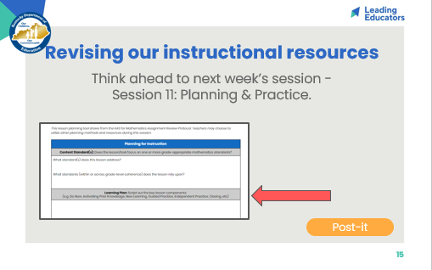
Slide 16:  (3 min) Facilitator says:  - “Let’s share out how we might review and then adjust our current materials.”  - Allow teachers to share. After sharing, [click through animation] provide sample guiding questions and draw parallels from discussion.  - “In thinking back to your curriculum, where do you anticipate you’ll need to make the most revisions?”  *Note for 9-12: Listen for and reinforce these key ideas…  - Possible answers:  - My tasks don’t always provide opportunities to demonstrate conceptual understanding - we solve equations by isolating the variable (procedural), but we don’t always make connections among representations and/or interpret our answers in the context of the problem.  - My tasks don’t explicitly ask students to explain or justify their answer. I could easily add language to a task that asks for verbal explanation. I could also rewrite some tasks so that they ask students to evaluate a sample student’s work so they can critique and provide feedback.  - *It is important to iterate for teachers that their curriculum may have KAS-aligned tasks that are ready for implementation and other times the curriculum may need tasks to be revised or created to align the KAS. Within one curriculum, alignment of lessons and tasks may vary from topic to topic. Teachers are encouraged to use the Assignment Review Protocol to evaluate tasks within their curriculum to ensure alignment to the KAS before using those tasks with students. Alternatively, teachers may use the Assignment Review Protocol as a rubric to support the revision and/or creation of new tasks. | 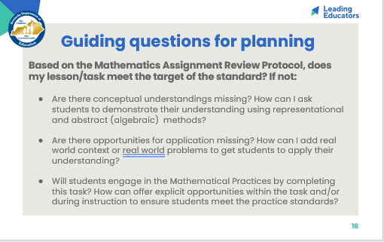
Slide 17:  (2 min) Allow teachers 1 minute to jot their reflection on their handout.  (3 min) Teachers share with an elbow partner or out loud. | 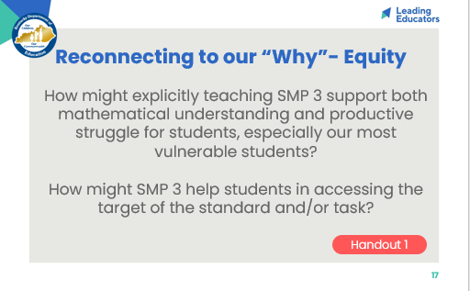
Slide 18:
(5 min) Teachers read aloud CFS - teacher and student look-fors. Provide teachers with an opportunity to discuss look-fors, connect look-fors to today’s session, and add look-fors.

Slide 19:  (3 min) Facilitator says:  - “On the Reflection and Looking Ahead handout, please select 2-3 indicators that you’d like to focus on as goals for this topic’s 3-week cycle. Then take a few minutes to complete the entire reflection.”  *Note: Facilitators may choose to  - Collect page 4 of Handout 1 as an artifact of teacher learning  - Have teachers bring this reflection to 1:1 coaching meetings  - Have teachers bring this reflection to future Planning & Practice and Student Progress sessions | 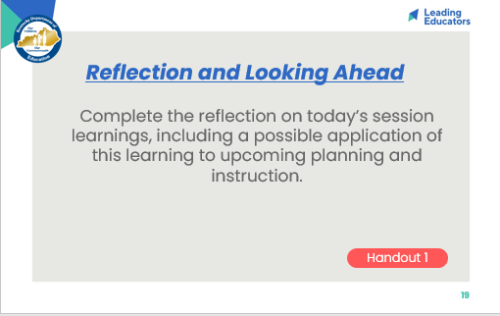
Slide 20:  (5 min) Facilitator says:  - “For today’s closing whip-around, I want to connect all of our new learning to equity, which is the driving force that pushes us to do this work and grow our practice. This is our why. Take a moment to read our closing question; then I’d like for us to whip around and share our thoughts/build upon one another’s.”  Teachers share out. | 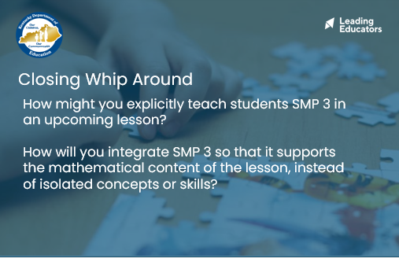
Slide 21:  (2 min) Facilitator previews next session and reminds teachers of any pre-work/action items to be completed before the next meeting. | 